Report
MULTIFUNCTIONAL ENDOSCOPIC DEVICE
Device
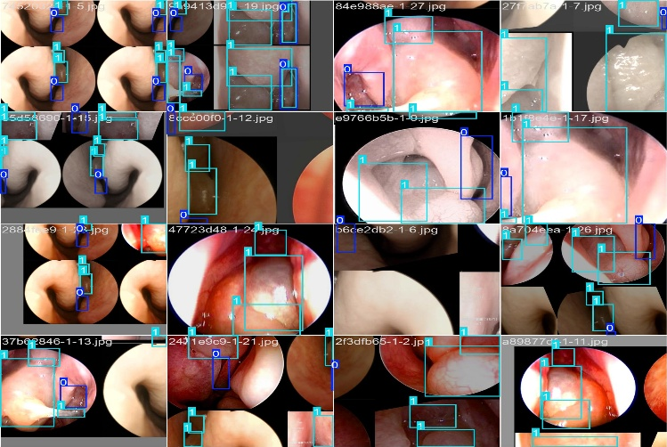
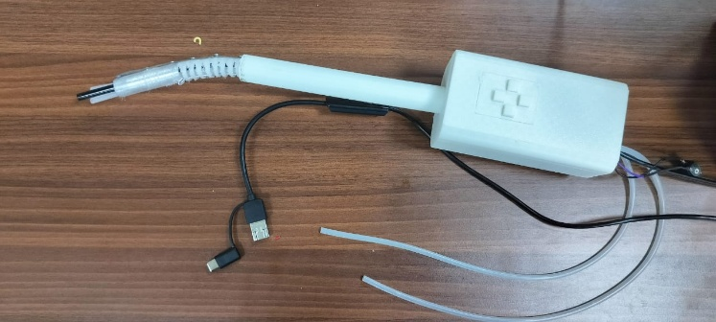
Sinusitis is caused by excessive mucus buildup and inflammation of the sinus lining. In India, nearly 80% of the population experiences sinusitis annually. Diagnosis and treatment typically require 2–4 days and can often be managed within a single clinical appointment. However, the use of multiple devices and steps during the process can increase patient discomfort and psychological stress.
AI Model for Detecting Polyps Nasal Septum
Development:
- Semi-rigid, articulating distal tip
- In-built suction and irrigation system for nasal endoscope
- Artificial intelligence for polyp detection in the nasal septum
- Automatic lens cleaning mechanism

Featuring:
Optimized Cross-section
- Integrated suction, irrigation, and inspection device with dedicated channels to prevent cross-contamination between functional pathways during procedures.
Rigid-Flexible Wrist
- Rigid shaft with a flexibly controlled wrist designed to access the sinus cavity, offering optimal maneuverability, enhanced reach, and precise navigation in complex anatomical regions.
Multi-Level Suction
- The system features dual suction levels: primary for removing mucus and abnormal bodies, and secondary tube advanced to extract from the sinus surface.

